EXP 02 :
Implement a basic finite state automaton that recognizes a specific language or pattern. In this example, we&#39;ll create a simple automaton to match strings ending with &#39;ab&#39; using python.

Aim: To implement a finite state automaton in Python to recognize strings ending with ab.

Algorithm:
- Define the input string and initialize the starting state.
- Read each character of the string.
- Change the state according to the input character.
- Check whether the final state represents acceptance.
- Display whether the string is accepted or rejected.

Program:
def check_string(s):
state = 0
for ch in s:
if state == 0:
state = 1 if ch == 'a' else 0
elif state == 1:
state = 2 if ch == 'b' else (1 if ch == 'a' else 0)
elif state == 2:
state = 1 if ch == 'a' else 0
if state == 2:
print(s, "is accepted")
else:
print(s, "is rejected")
check_string("abab")
check_string("aab")
check_string("abba")

OUTPUT:
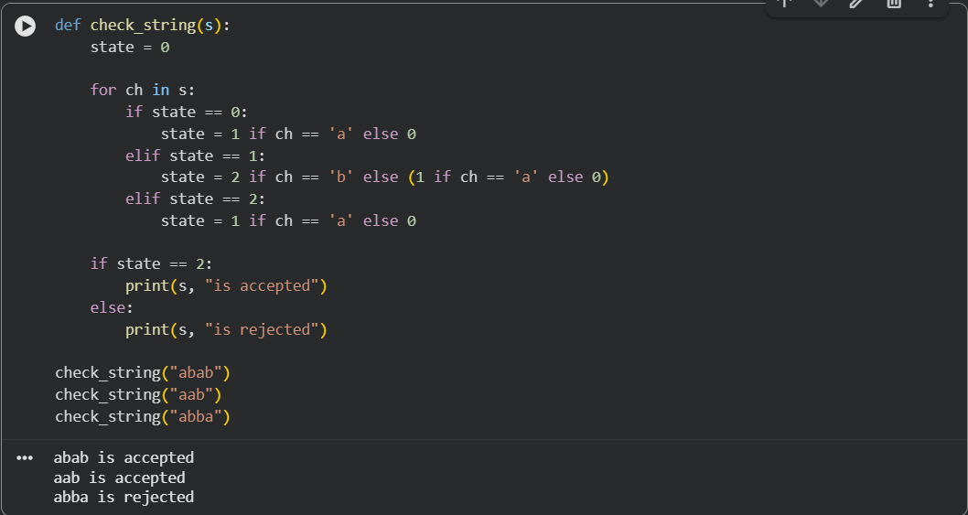

Result: Thus, the finite state automaton was implemented successfully to recognize strings ending with ab.

